Research data:

Finding homologs between sequences for chr8 700,001..795,000

Chr8 sequence Annotations

Annotation: chr8

PASTE CODING REGION HERE:



[chr8:49455025-49458016 - strand] [peptide]

IsoSeq Top Tier Results

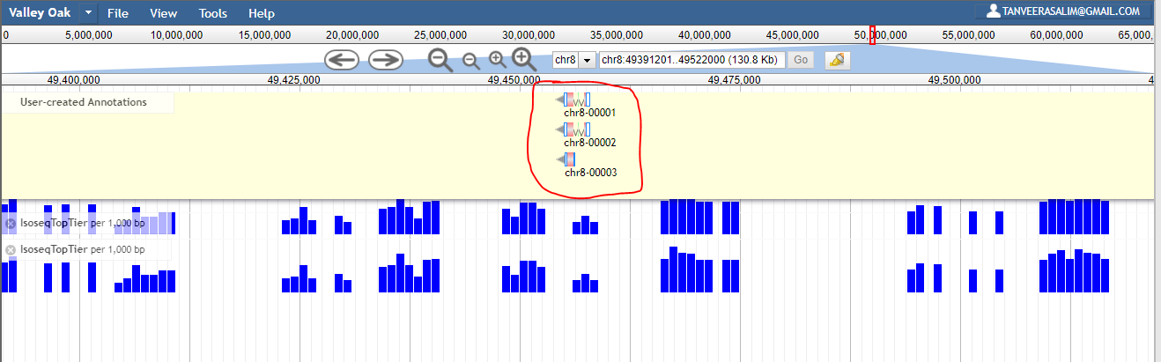

IsoSeq Top Tier Results Close-Up

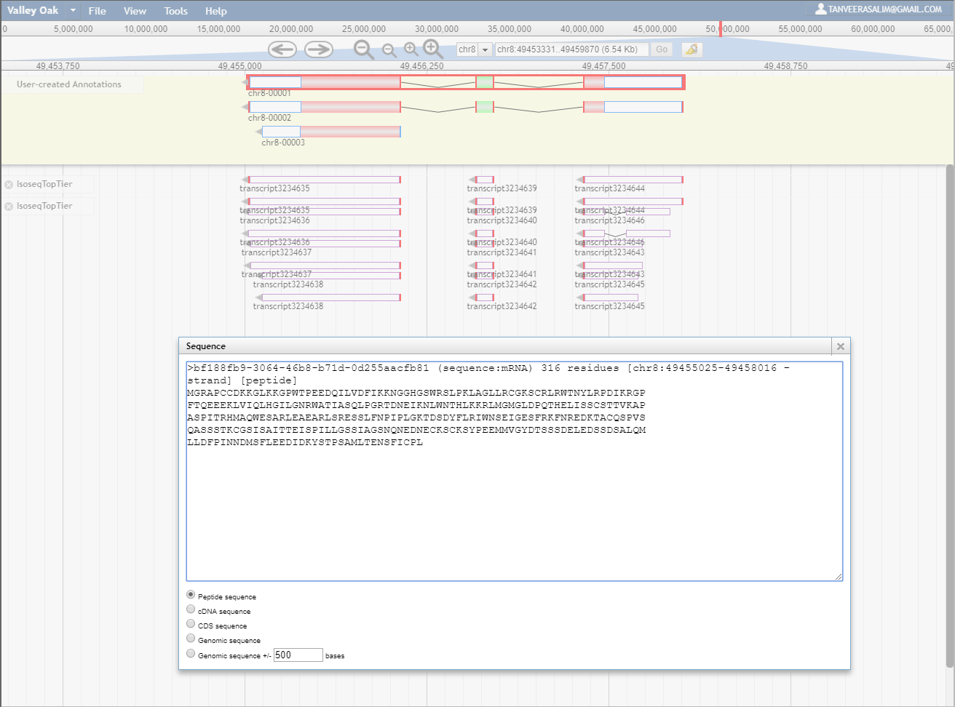

Peptide Sequences being Compared:

>bf188fb9-3064-46b8-b71d-0d255aacfb81 (sequence:mRNA) 316 residues [chr8:49455025-49458016 - strand] [peptide]

MGRAPCCDKKGLKKGPWTPEEDQILVDFIKKNGGHGSWRSLPKLAGLLRCGKSCRLRWTNYLRPDIKRGP

FTQEEEKLVIQLHGILGNRWATIASQLPGRTDNEIKNLWNTHLKKRLMGMGLDPQTHELISSCSTTVKAP

ASPITRHMAQWESARLEAEARLSRESSLFNPIPLGKTDSDYFLRIWNSEIGESFRKFNREDKTACQSPVS

QASSSTKCGSISAITTEISPILLGSSIAGSNQNEDNECKSCKSYPEEMMVGYDTSSSDELEDSSDSALQM

LLDFPINNDMSFLEEDIDKYSTPSAMLTENSFICPL

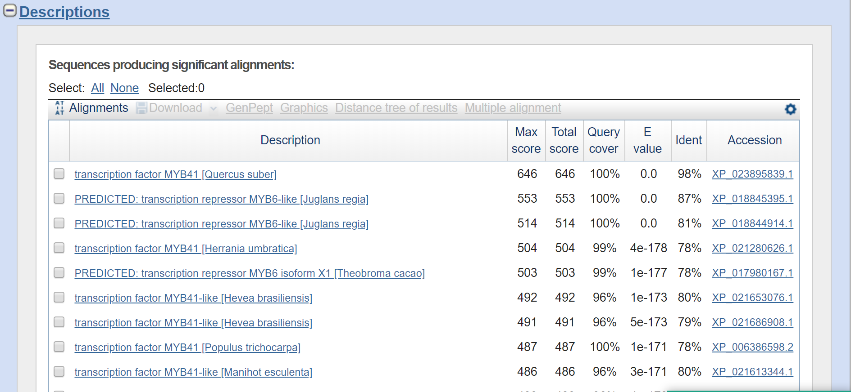

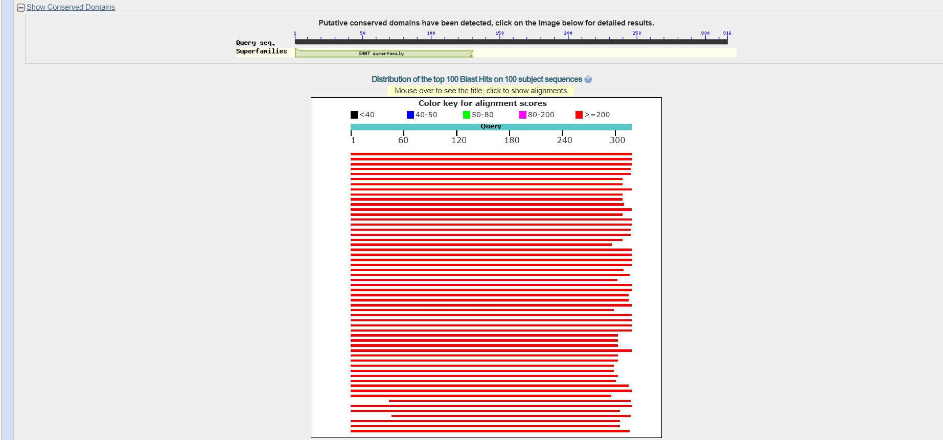

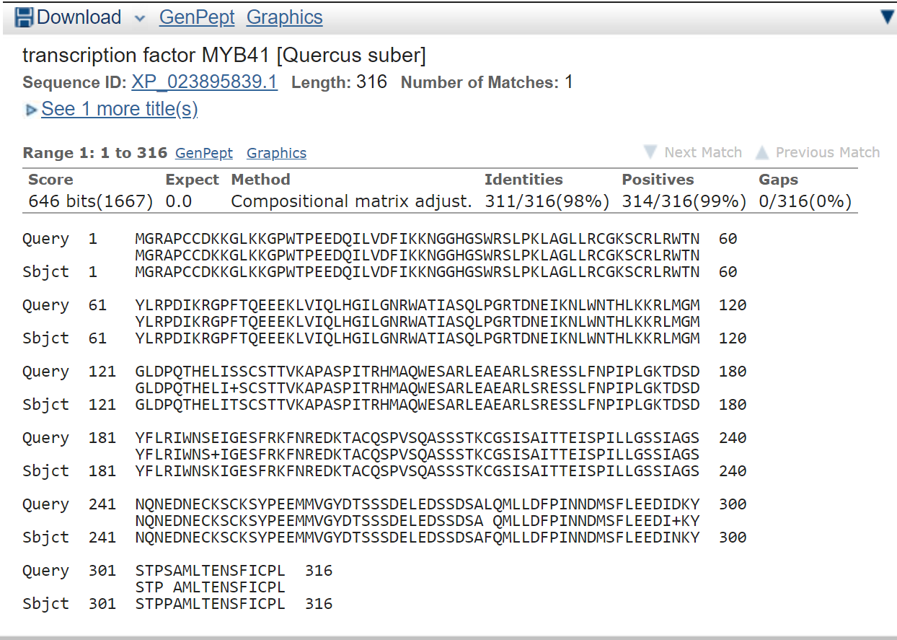

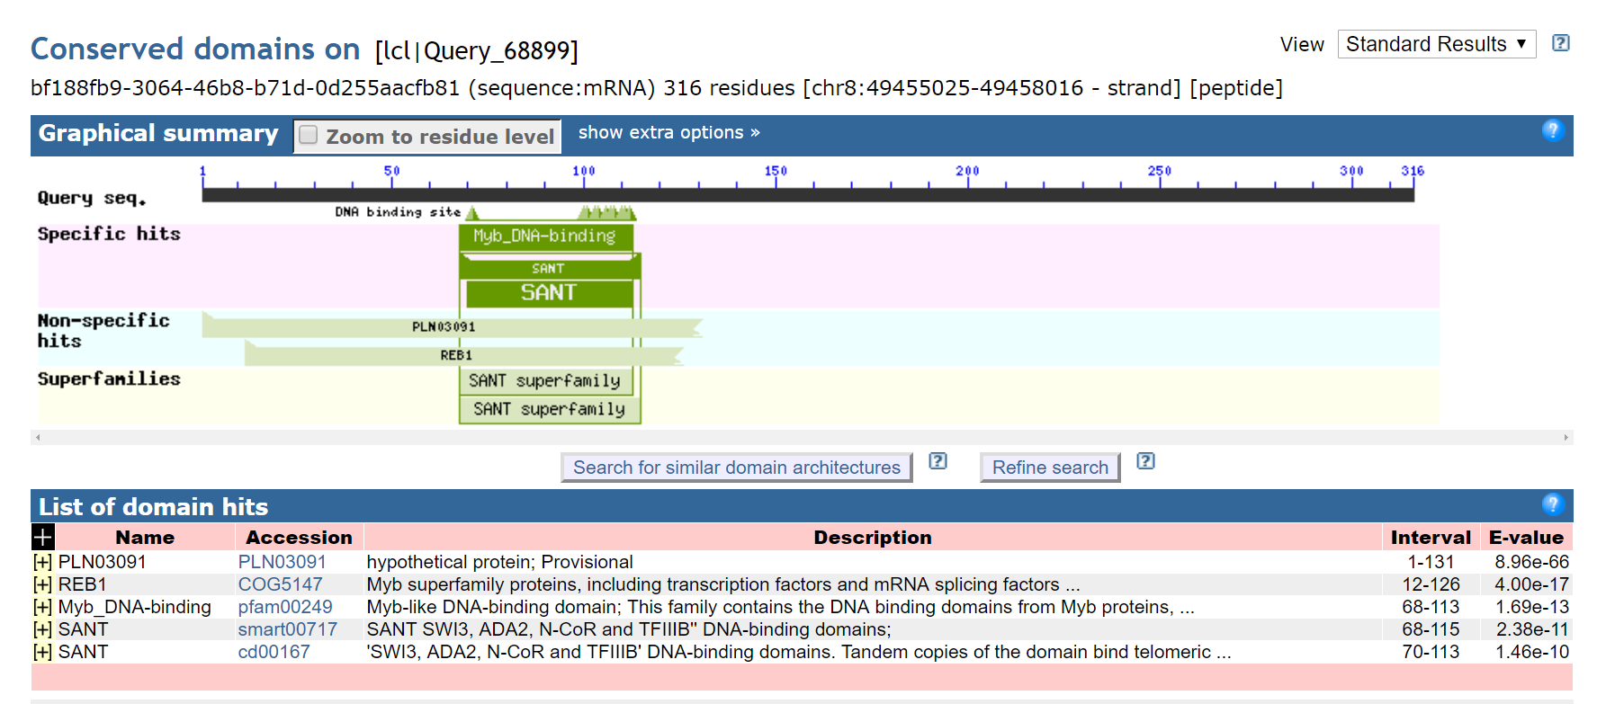

-----------------------------------------------------------------------------------------------------------------------------------

**casein kinase 1-like protein HD16**

>XP_023885896.1 casein kinase 1-like protein HD16 [Quercus suber] (Cork Oak)

MPELRSGARRSKRVDDLYPAPQPIDQGDNWLLPAQNRTRRRAAGRGRAGGNAALAKGPSPAVLTRPTAAA

RGRGIRLIDLDPEPCEVLPEAVALGAAEPLYNQVEVVADIDIGMEGGSADKVMGVEEEASTTPVPERVKV

GNSPVYKIERKLGKGGFGQVYVGRRVSGGTDADVTEVALKFEHRNSKGCNYGPPYEWQVYNTLNGCYGIP

WVHYKGRQGDFYILVMDILGPSLWDVWNSFGQSMSPNMAACIAVEAISILEKLHLKGFVHGDVKPENFLL

GQPGTPDEKKLYLIDLGLASRWKDASSGQHVEYDQRPDIFRGTIRYASVHAHLGRTGSRRDDLESLAYTL

IFLIRGRLPWQGYQGDNKSFLVCKKKMATSPELMCCFCPPPFKQFLEAVTNMKFDEEPNYSKLISFFESL

IEPCTPLRPIRIDGALKVGQKRARLLINLEEDEQPKKKVRLGSPATQWISVYNARRPMKQRYHYNVADTR

LHQHVDKGNEDGLYISCVASATNLWALIMDAGTGFSSQVYELSAVFLHKDWIMEQWEKNFYISSIAGAAN

GSSLVVMSKGTPYTQQSYKVSESFPFKWINKKWKEGFHVTSMTTAGSRWGVVMSRNAGYSDQVVELDFLY

PSEGIHRRWESGYRITSMAATADQGAFILSIPKRKTMDETQETLRTSAFPSTHVKEKWSKNLYIASICYG

RTVC

Multiple Sequence Alignment File For Chr8 Annotation: bf188fb9-3064-46b8-b71d-0d255aacfb81

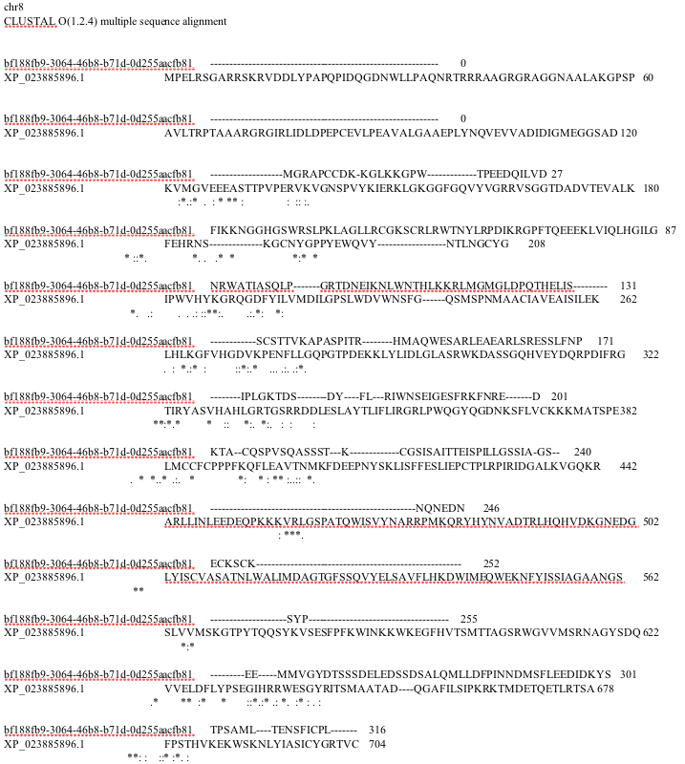

*************************************************************************************

Annotation: chr8a

Chr8a: [9262103-9267776 + strand] [peptide]

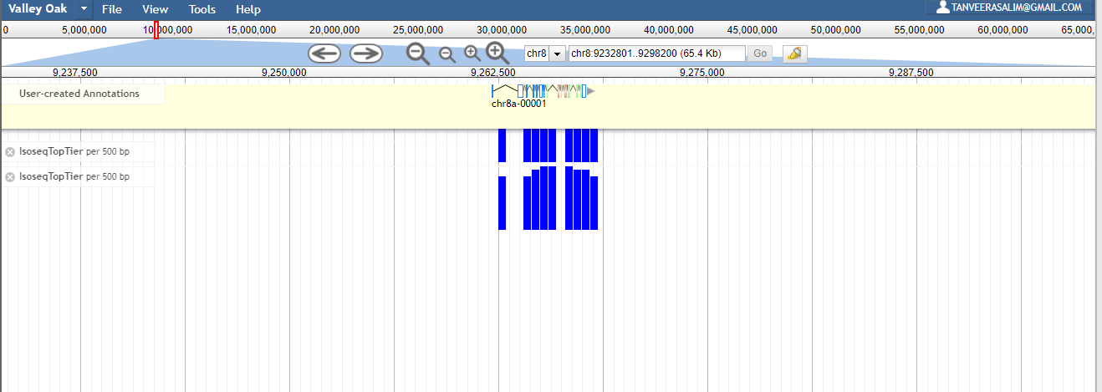

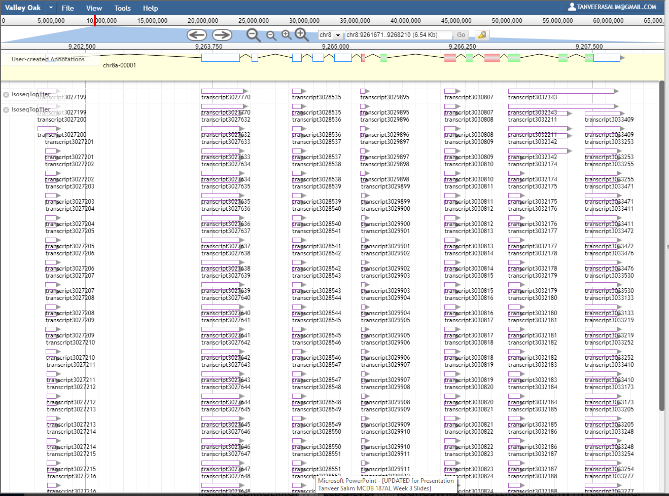

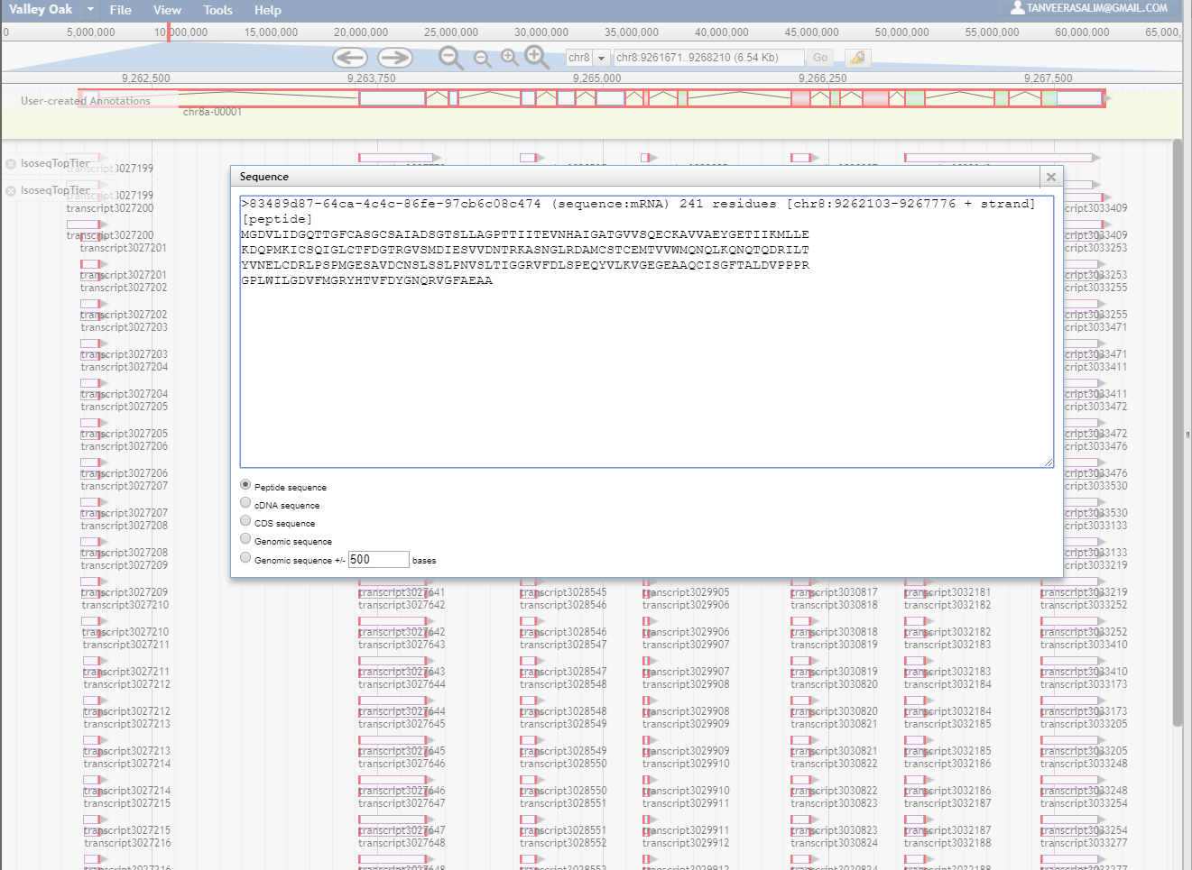

Peptide Sequences Being Compared:

>83489d87-64ca-4c4c-86fe-97cb6c08c474 (sequence:mRNA) 241 residues [chr8:9262103-9267776 + strand] [peptide]

MGDVLIDGQTTGFCASGCSAIADSGTSLLAGPTTIITEVNHAIGATGVVSQECKAVVAEYGETIIKMLLE

KDQPMKICSQIGLCTFDGTRGVSMDIESVVDNTRKASNGLRDAMCSTCEMTVVWMQNQLKQNQTQDRILT

YVNELCDRLPSPMGESAVDCNSLSSLPNVSLTIGGRVFDLSPEQYVLKVGEGEAAQCISGFTALDVPPPR

GPLWILGDVFMGRYHTVFDYGNQRVGFAEAA

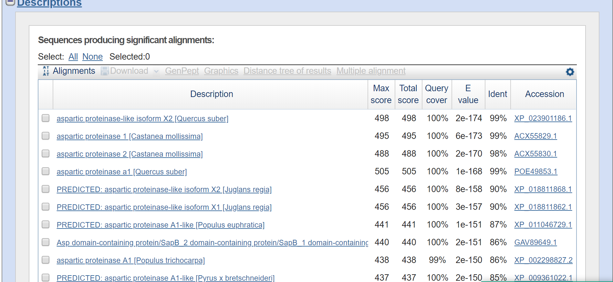

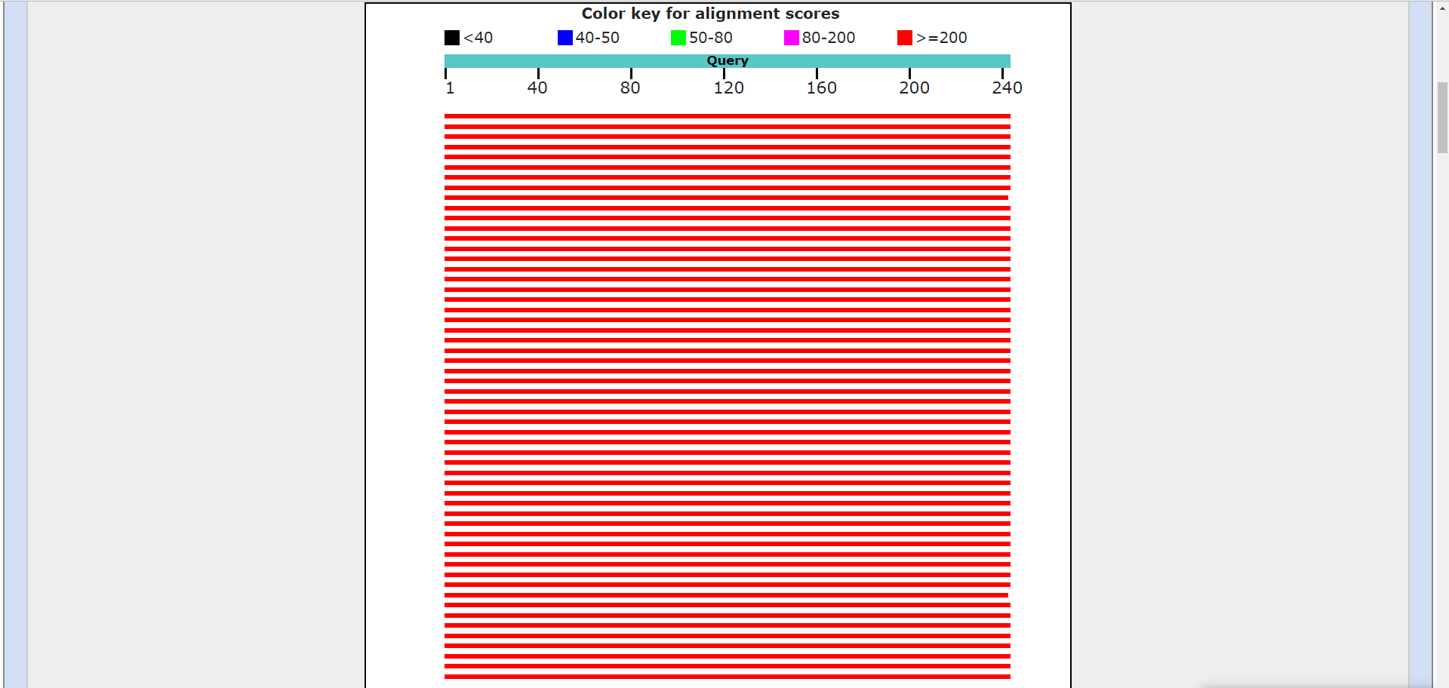



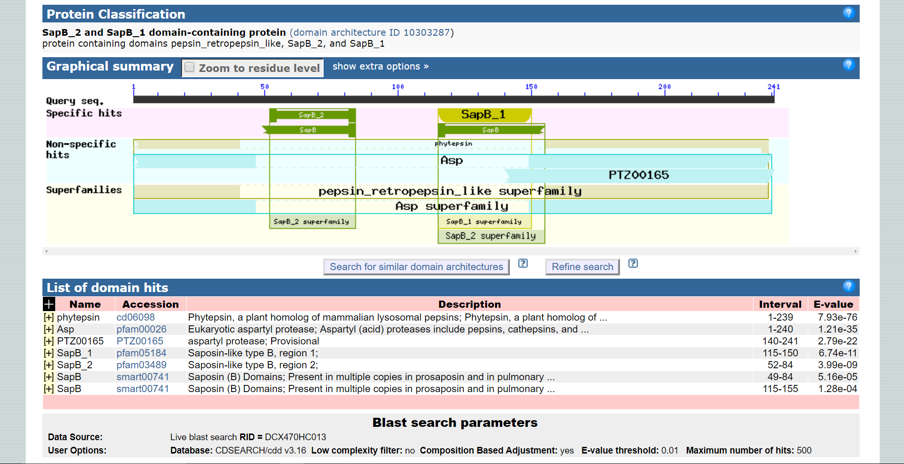

-------------------------------------------------------------------------------------------------------------------------------

**aspartic proteinase-like isoform X2 [Quercus suber]**

>XP_023901186.1 aspartic proteinase-like isoform X2 [Quercus suber]

MGNKLKTVVATFFLCFLLFPLVFSASNGGLVRIGLKKTKLDKNNRVAAQLESKDGEVRSASIRKYYLRGN

SGDPEDIDIVSLKNYMDAQYFGEIGVGTPPQKFTVIFDTGSSNLWVPSSKCYFSVACYFHSKYKSSSSST

YKKNGKPADIHYGTGAISGYFSQDHVKVGDLVVKNQEFIEATREPSITFLVAKFDGILGLGFKEISVGNA

VPLWYNMVKQGLVKEPVFSFWFNRNTDEEEGGEIVFGGVDPNHYKGKHTYVPVTQKGYWQFDMGDVLIDG

QTTGFCASGCSAIADSGTSLLAGPTTIITEVNHAIGATGVVSQECKAVVAEYGETIIKMLLEKDQPMKIC

SQIGLCTFDGTRGVSMDIESVVDNTRKASNGLRDAMCSTCEMTVVWMQNQLKQNQTQDRILTYVNELCDR

LPSPMGESAVDCGSLSSLPNVSLTIGGRVFDLSPEQYVLKVGEGEAAQCISGFTALDVPPPRGPLWILGD

VFMGRYHTVFDYGNQRVGFAEAA

Multiple Sequence Alignment File For Chr8a Annotation: 83489d87-64ca-4c4c-86fe-97cb6c08c474

